NAME - SHRESTHA DEY
SupersetID - 7719638
DN-5.0 JavaFSE Solutions

WEEK-1 : DATA STRUCTURES AND ALGORITHMS

Exercise 1: Inventory Management System
Analysis:
Data Structure used : HashMap
(Why HashMap? ArrayList gives O(n) for search/delete. HashMap keys on productId, making all core ops O(1) average — ideal for large warehouses.)
- add() → O(1) average. HashMap computes the hash of the key and places it directly. No iteration needed.
- update() → O(1) average. Same as add — hash lookup + field update.
- delete() → O(1) average. Hash computed, bucket found, node removed.
- Worst case for all three is O(n) due to hash collisions, but rare with a good hash function.
- ArrayList would give O(n) for search and delete, making HashMap clearly superior for large inventories.
Code Snippet :
import java.util.HashMap;
class Product {
int productId;
String productName;
int quantity;
double price;
Product(int id, String name, int qty, double price) {
this.productId = id;
this.productName = name;
this.quantity = qty;
this.price = price;
}
}
class Inventory {
private HashMap<Integer, Product> store = new HashMap<>();
// O(1) average
void add(Product p) {
store.put(p.productId, p);
}
// O(1) average
void update(int id, int qty, double price) {
Product p = store.get(id);
if (p != null) { p.quantity = qty; p.price = price; }
}
// O(1) average
void delete(int id) {
store.remove(id);
}
Product get(int id) { return store.get(id); }
}

Implementation:
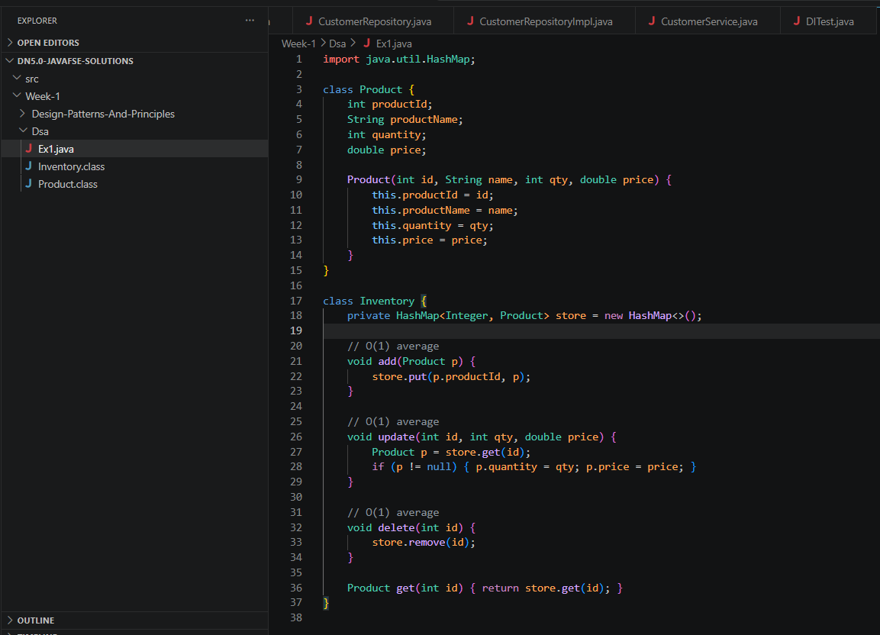

Exercise 2: E-commerce Platform Search Function
Analysis:
Data Structure Used - Array (Linear Search and Binary Search)
Linear search is O(n) and works on any data; binary search is O(log n) but needs a sorted array. For a million products, binary needs ~20 comparisons vs up to 1,000,000.
- Linear search best case: O(1) — item found at index 0. Average and worst: O(n).
- Binary search best case: O(1) — item is the middle element. Average and worst: O(log n).
- Binary search requires the array to be sorted, which costs O(n log n) once. After that, every search is O(log n).
- For a catalogue of 1 million products, binary search takes at most 20 comparisons; linear takes up to 1,000,000.
Recommendation: Use binary search for large, stable catalogues. Use linear only for small or frequently changing unsorted data.
Code Snippet:
class Product {
int productId;
String productName;
String category;
Product(int id, String name, String cat) {
this.productId = id; this.productName = name; this.category = cat;
}
}
class SearchEngine {
// Linear search — O(n), works on unsorted data
static Product linearSearch(Product[] arr, String name) {
for (Product p : arr)
if (p.productName.equalsIgnoreCase(name)) return p;
return null;
}
// Binary search — O(log n), requires sorted array
static Product binarySearch(Product[] arr, String name) {
int lo = 0, hi = arr.length - 1;
while (lo <= hi) {
int mid = (lo + hi) / 2;
int cmp = arr[mid].productName.compareToIgnoreCase(name);
if (cmp == 0) return arr[mid];
else if (cmp < 0) lo = mid + 1;
else hi = mid - 1;
}
return null;
}
}
Implementation:
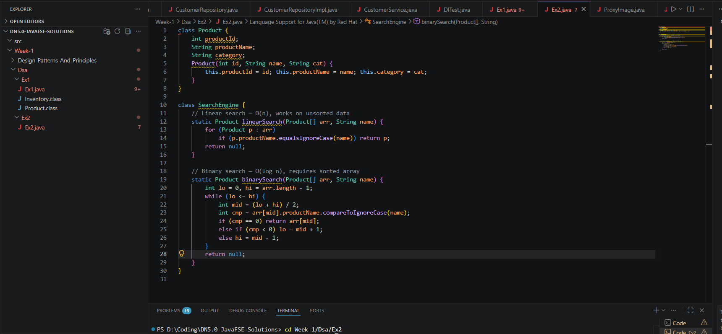

Exercise 3: Sorting Customer Orders
Analysis:
Data Structure Used: Array (Bubble Sort and Quick Sort)
- Bubble Sort is O(n²) — avoid on large datasets. Quick Sort is O(n log n) average and is what Java's own Arrays.sort() is based on.
- Bubble Sort best case: O(n) — already sorted. Average and worst: O(n²). Space: O(1).
- Quick Sort best case: O(n log n). Average: O(n log n). Worst case: O(n²) — when pivot is always the smallest or largest element (rare with good pivot choice). Space: O(log n) stack.
- For 1000 orders, Bubble Sort does ~500,000 comparisons; Quick Sort does ~10,000.
- Recommendation: Always prefer Quick Sort for real workloads. Bubble Sort is only useful for teaching or nearly-sorted tiny lists. Java's Arrays.sort() uses a dual-pivot Quick Sort internally.

Code Snippet:
public class Ex3 {
static class Order {
int orderId;
String customerName;
double totalPrice;
Order(int id, String name, double price) {
this.orderId = id;
this.customerName = name;
this.totalPrice = price;
}
}
// Bubble Sort — O(n²)
static void bubbleSort(Order[] arr) {
int n = arr.length;
for (int i = 0; i < n - 1; i++)
for (int j = 0; j < n - i - 1; j++)
if (arr[j].totalPrice > arr[j+1].totalPrice) {
Order tmp = arr[j]; arr[j] = arr[j+1]; arr[j+1] = tmp;
}
}
// Quick Sort — O(n log n) average
static void quickSort(Order[] arr, int lo, int hi) {
if (lo < hi) {
int p = partition(arr, lo, hi);
quickSort(arr, lo, p - 1);
quickSort(arr, p + 1, hi);
}
}
static int partition(Order[] arr, int lo, int hi) {
double pivot = arr[hi].totalPrice;
int i = lo - 1;
for (int j = lo; j < hi; j++)
if (arr[j].totalPrice <= pivot) {
i++; Order tmp = arr[i]; arr[i] = arr[j]; arr[j] = tmp;
}
Order tmp = arr[i+1]; arr[i+1] = arr[hi]; arr[hi] = tmp;
return i + 1;
}
public static void main(String[] args) {
Order[] orders = {
new Order(1, "Alice", 59.99),
new Order(2, "Bob", 39.99),
new Order(3, "Carol", 79.99)
};
quickSort(orders, 0, orders.length - 1);
for (Order order : orders) {
System.out.println(order.orderId + " " + order.customerName + " " + order.totalPrice);
}
}
}
Implementation:
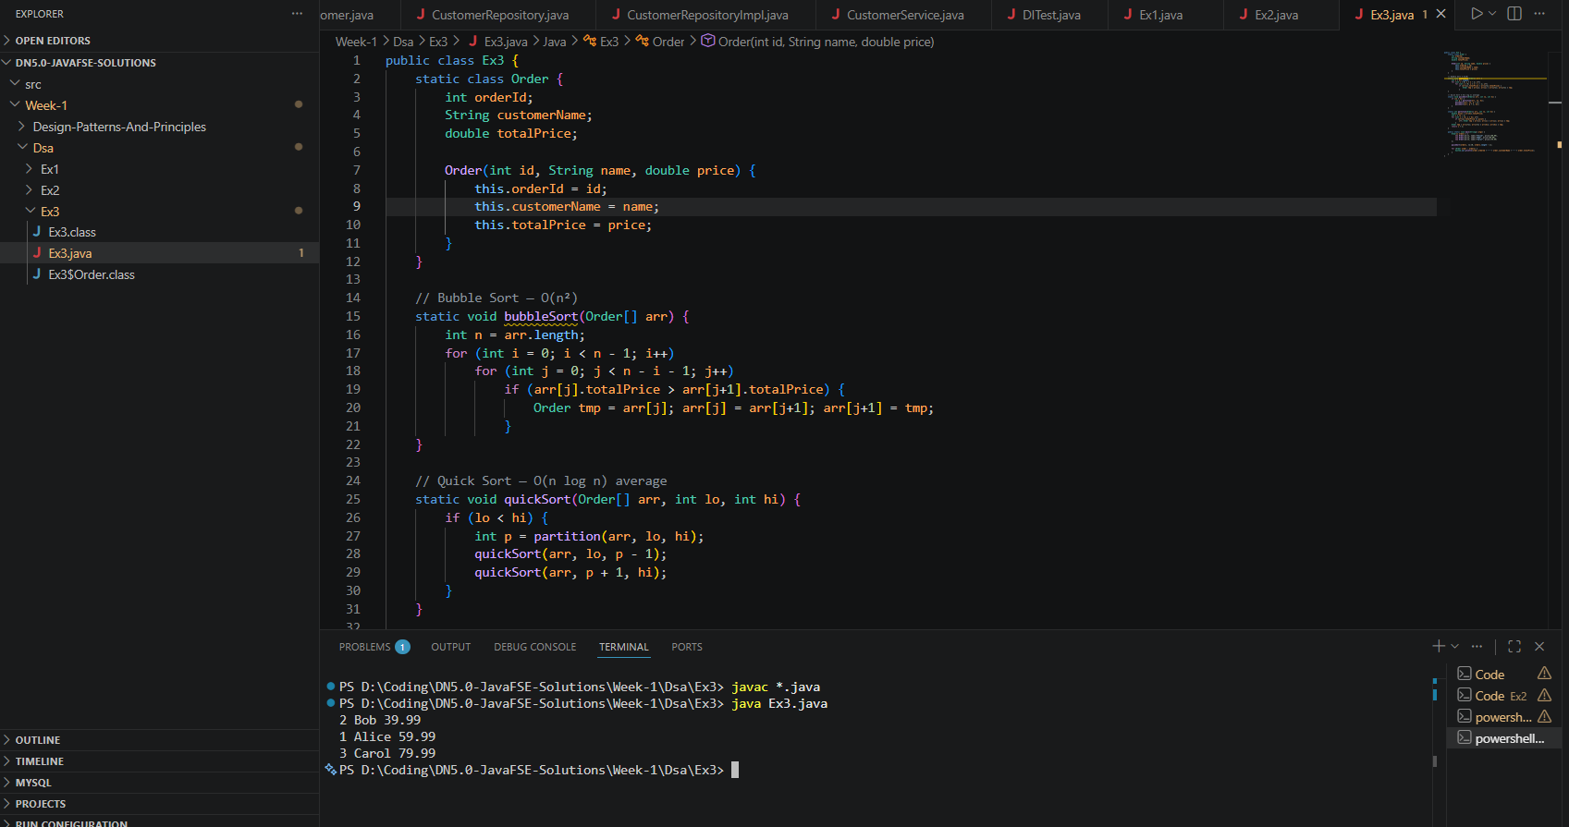
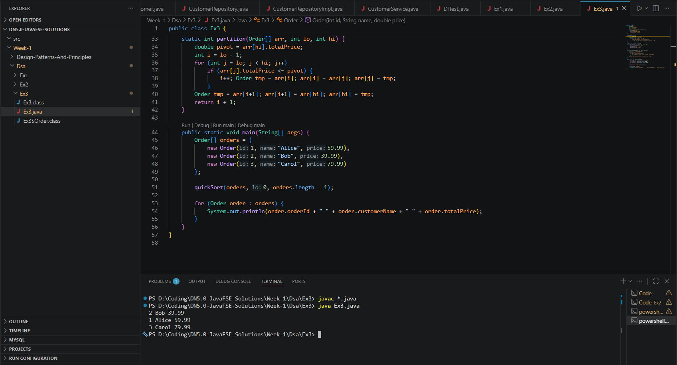

Exercise 4: Employee Management System
Analysis:
Data Structure Used: Arrays
Arrays give O(1) add and cache-friendly traversal, but O(n) search/delete and a fixed size. Good for small, stable record sets.
- add() at end → O(1). No shifting needed.
- search() → O(n). Must scan every element until found.
- delete() → O(n). Finding the element is O(n), then shifting all elements after it is also O(n).
- traverse() → O(n). Every element visited once.
- Arrays have O(1) random access by index and excellent cache locality (elements stored contiguously in memory).
- Limitation: Fixed size at creation. If you need to grow dynamically, use ArrayList. If you need fast search/delete, use HashMap.
Code Snippet:
class Employee {
int employeeId;
String name, position;
double salary;
Employee(int id, String name, String pos, double sal) {
this.employeeId = id; this.name = name;
this.position = pos; this.salary = sal;
}
}
class EmployeeManager {
private Employee[] arr;
private int size = 0;
EmployeeManager(int capacity) { arr = new Employee[capacity]; }
// O(1) — add at end
void add(Employee e) {
if (size < arr.length) arr[size++] = e;
}
// O(n) — linear scan
Employee search(int id) {
for (int i = 0; i < size; i++)
if (arr[i].employeeId == id) return arr[i];
return null;
}
// O(n) — shift elements after deletion
void delete(int id) {
for (int i = 0; i < size; i++) {
if (arr[i].employeeId == id) {
for (int j = i; j < size - 1; j++) arr[j] = arr[j+1];
arr[--size] = null; return;
}
}
}
// O(n) — visit every element
void traverse() {
for (int i = 0; i < size; i++)
System.out.println(arr[i].name + " | " + arr[i].position);
}
public static void main(String[] args) {
EmployeeManager manager = new EmployeeManager(5);
manager.add(new Employee(1, "Alice", "Developer", 75000));
manager.add(new Employee(2, "Bob", "Tester", 65000));
manager.traverse();
}
}
Implementation:
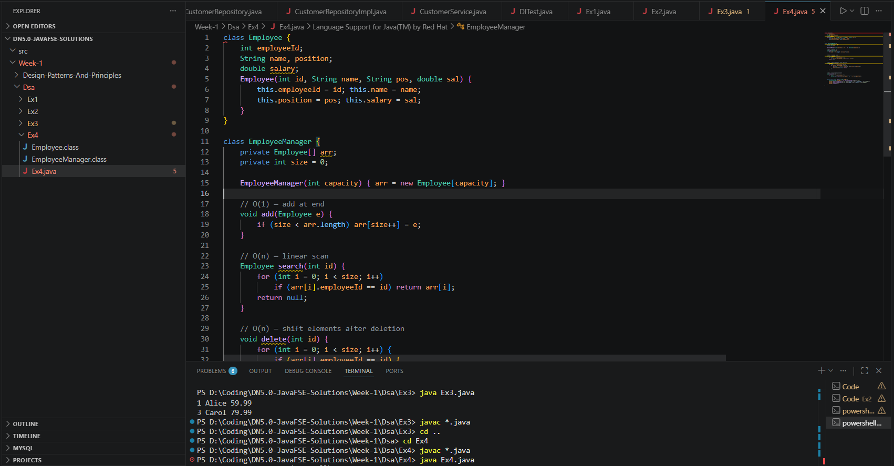
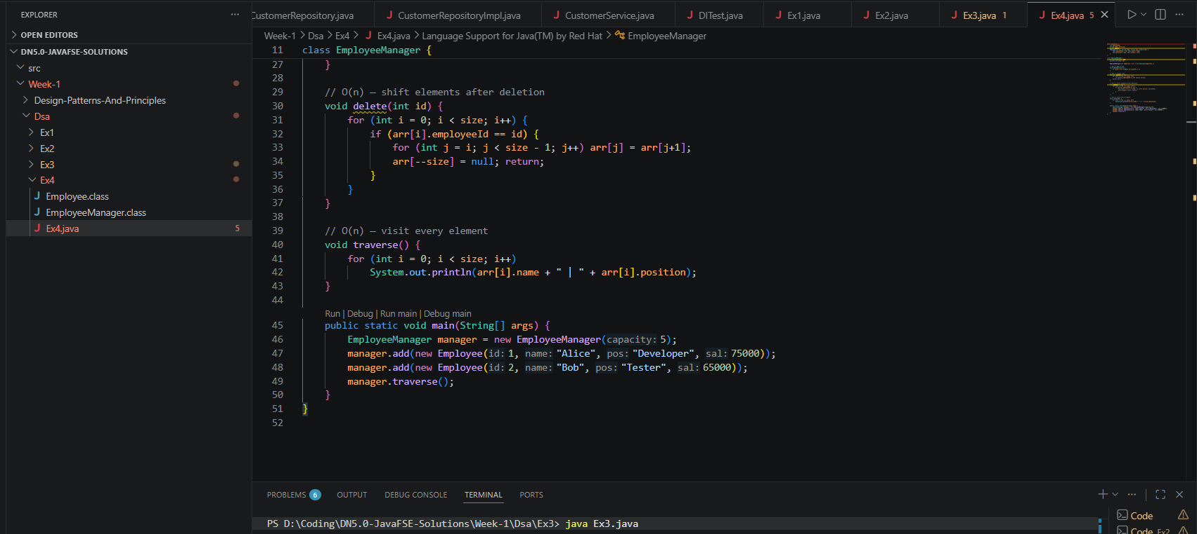

Exercise 5: Task Management System
Analysis:
Data Structure Used: Linked List
Singly linked lists give O(1) head insertion and don't need shifting on delete — ideal for dynamic task queues where size is unpredictable.

- addFirst() → O(1). Just update the head pointer.
- addLast() → O(n). Must traverse to the end. Can be made O(1) by keeping a tail pointer.
- search() → O(n). No random access — must walk node by node.
- delete() → O(n) to find the node, then O(1) to unlink it (just redirect a pointer).
- traverse() → O(n).
- Advantage over arrays: No shifting on delete, no fixed size, O(1) insertion at head. Ideal when task count is unknown or changes frequently.
- Disadvantage: No random access, extra memory per node for the next pointer.

Code Snippet :

class Task {
int taskId;
String taskName, status;
Task next;
Task(int id, String name, String status) {
this.taskId = id; this.taskName = name;
this.status = status; this.next = null;
}
}
class TaskList {
private Task head = null;
// O(1) — insert at head
void addFirst(Task t) { t.next = head; head = t; }
// O(n) — insert at tail
void addLast(Task t) {
if (head == null) { head = t; return; }
Task cur = head;
while (cur.next != null) cur = cur.next;
cur.next = t;
}
// O(n) — linear scan
Task search(int id) {
Task cur = head;
while (cur != null) {
if (cur.taskId == id) return cur;
cur = cur.next;
}
return null;
}
// O(n) — find and unlink node
void delete(int id) {
if (head == null) return;
if (head.taskId == id) { head = head.next; return; }
Task cur = head;
while (cur.next != null) {
if (cur.next.taskId == id) { cur.next = cur.next.next; return; }
cur = cur.next;
}
}
void traverse() {
Task cur = head;
while (cur != null) {
System.out.println(cur.taskId + ": " + cur.taskName + " [" + cur.status + "]");
cur = cur.next;
}
}
}
Implementation:
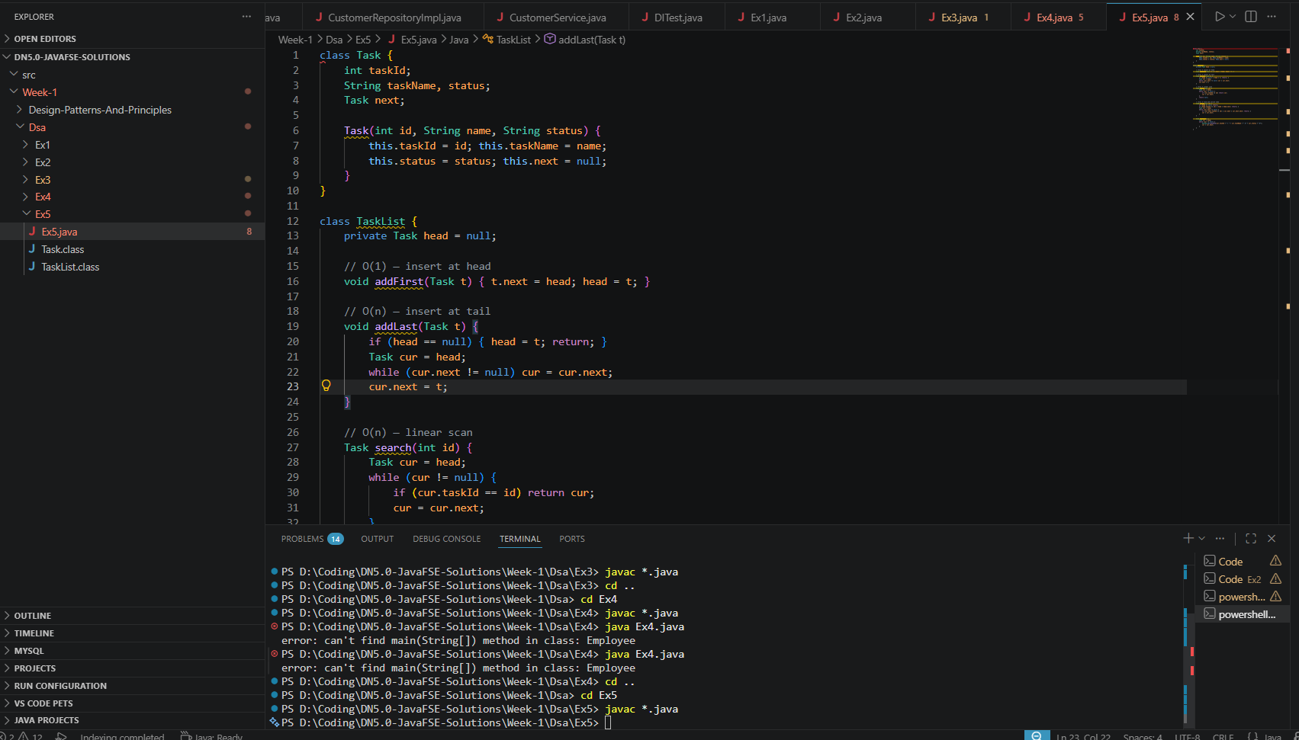
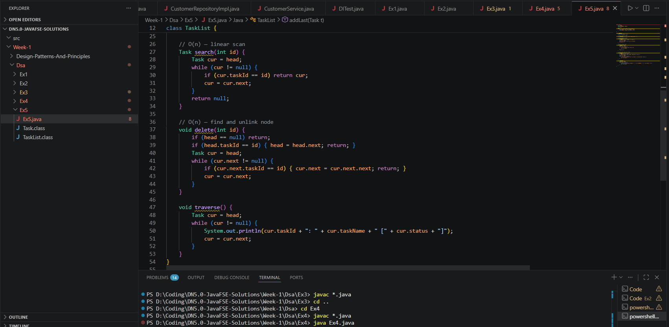

Exercise 6: Library Management System
Analysis:
Data Structure Used : Arrays (Linear Search and Binary Search)
Choose linear for small/unsorted collections, binary for large sorted ones. The one-time O(n log n) sort pays off after just a handful of lookups.
- Same complexity as Exercise 2, but applied to books by title.
- Linear: O(n) — no sorting needed, works for any collection size.
- Binary: O(log n) per search after an O(n log n) one-time sort.
- When to use linear: Small library (under ~100 books), or catalogue changes frequently (new books added/removed often, making it hard to keep sorted).
- When to use binary: Large library, stable catalogue, or if books are already stored in sorted order (e.g., a database with an index).
Code Snippet :
import java.util.Arrays;
import java.util.Comparator;
class Book {
int bookId;
String title, author;
Book(int id, String title, String author) {
this.bookId = id; this.title = title; this.author = author;
}
}
class Library {
Book[] books;
Library(Book[] books) { this.books = books; }
// O(n) — no sorting required
Book linearSearch(String title) {
for (Book b : books)
if (b.title.equalsIgnoreCase(title)) return b;
return null;
}
// O(log n) — array must be sorted by title first
Book binarySearch(String title) {
// Sort once: O(n log n)
Arrays.sort(books, Comparator.comparing(b -> b.title));
int lo = 0, hi = books.length - 1;
while (lo <= hi) {
int mid = (lo + hi) / 2;
int cmp = books[mid].title.compareToIgnoreCase(title);
if (cmp == 0) return books[mid];
else if (cmp < 0) lo = mid + 1;
else hi = mid - 1;
}
return null;
}
}

Implementation:
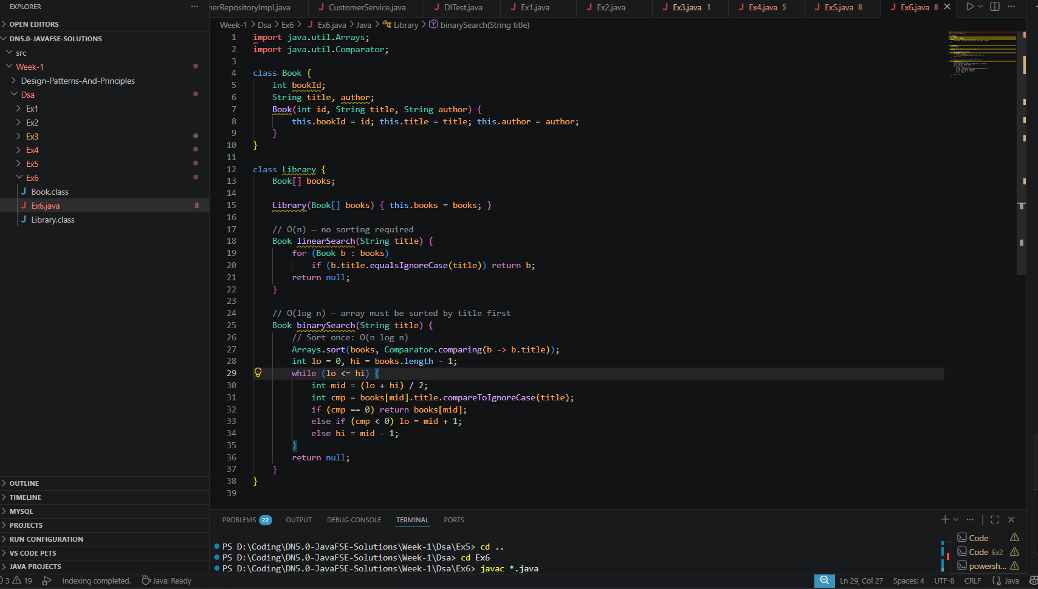

Exercise 7: Financial Forecasting
Analysis:
Data Structure Used:
- Recursion is clean for this problem since it's linear depth, but the iterative version is always safer in production (no stack overflow risk, O(1) space).
- Naive recursive futureValue() → O(n) time, O(n) space (call stack depth equals number of years).
- Risk: For very large years values (e.g., 10,000), this can cause a StackOverflowError.
- Memoized version → O(n) time, O(n) space for the memo table. Useful when the same sub-problems repeat (more relevant for branching recursions like Fibonacci).
- Iterative version → O(n) time, O(1) space. No stack risk, most efficient.
- Optimization: For this specific problem, there's actually a closed-form formula: FV = PV × (1 + rate)^years, computable in O(1) using Math.pow(). This is the best approach in production.

Code Snippet :
import java.util.HashMap;
class Forecast {
// Naive recursion — O(n) time, O(n) stack space
static double futureValue(double presentValue, double rate, int years) {
if (years == 0) return presentValue;
return futureValue(presentValue * (1 + rate), rate, years - 1);
}
// Memoized version — avoids re-computation in branching scenarios
private static HashMap<String, Double> memo = new HashMap<>();
static double futureValueMemo(double pv, double rate, int years) {
if (years == 0) return pv;
String key = pv + "," + rate + "," + years;
if (memo.containsKey(key)) return memo.get(key);
double result = futureValueMemo(pv * (1 + rate), rate, years - 1);
memo.put(key, result);
return result;
}
// Iterative (most practical) — O(n) time, O(1) space
static double futureValueIter(double pv, double rate, int years) {
double fv = pv;
for (int i = 0; i < years; i++) fv *= (1 + rate);
return fv;
}
public static void main(String[] args) {
// Predict value of $1000 after 10 years at 7% annual growth
System.out.printf("Future value: $%.2f%n",
futureValue(1000, 0.07, 10)); // $1967.15
}
}
Implementation:
